**DAILY ONLINE ACTIVITIES SUMMARY**

|  |  |  |  |  |  |  |  |
| --- | --- | --- | --- | --- | --- | --- | --- |
| **Date:** | **11/06/2020** | | | | **Name:** | **Churashma** | |
| **Sem & Sec** | **4th SEM 'A' Section** | | | | **USN:** | **4AL18CS019** | |
| **Online Test Summary** | | | | | | | |
| **Subject** | | **No test** | | | | | |
| **Max. Marks** | | **-** | | **Score** | | **-** | |
| **Certification Course Summary** | | | | | | | |
| **Course** | **Introduction to neural networks and deep learning** | | | | | | |
| **Certificate Provider** | | | **greatlearning academy** | **Duration** | | | **9.5 hours** |
| **Coding Challenges** | | | | | | | |
| **Problem statement 1: Write a Java Program to Segregate Even and Odd numbers.** | | | | | | | |
| **Status: completed** | | | | | | | |
| **Uploaded the report in Github** | | | | **yes** | | | |
| **If yes Repository name** | | | | **https://github.com/Churashma/Lockdown-coding** | | | |
| **Uploaded the report in slack** | | | | **yes** | | | |

ONLINE TEST DETAILS: No test

CERTIFICATION COURSE DETAILS: I started with new course that is introduction to neural networks and deep learning.In that I studied about Introduction to neural networks and also I studied about activation functions. The basic unit of computation in a neural network is the neuron, often called a node or unit. It receives input from some other nodes, or from an external source and computes an output.The activation function is a mathematical “gate” in between the input feeding the current neuron and its output going to the next layer. It can be as simple as a step function that turns the neuron output on and off, depending on a rule or threshold.

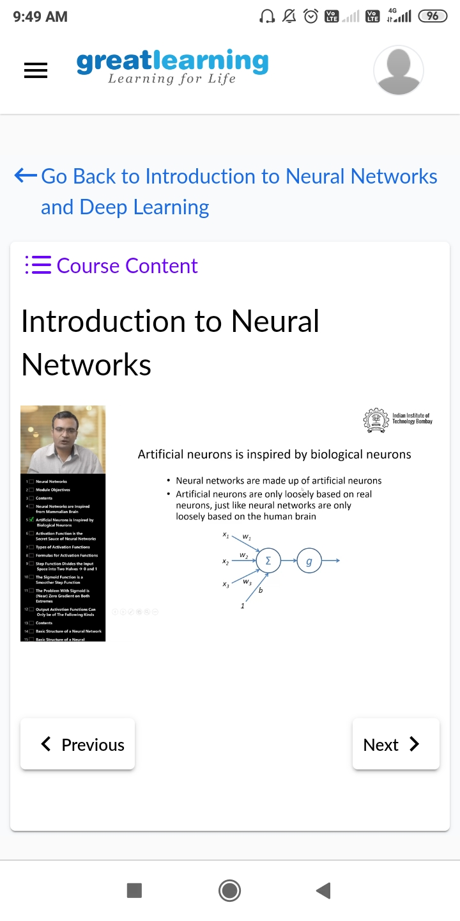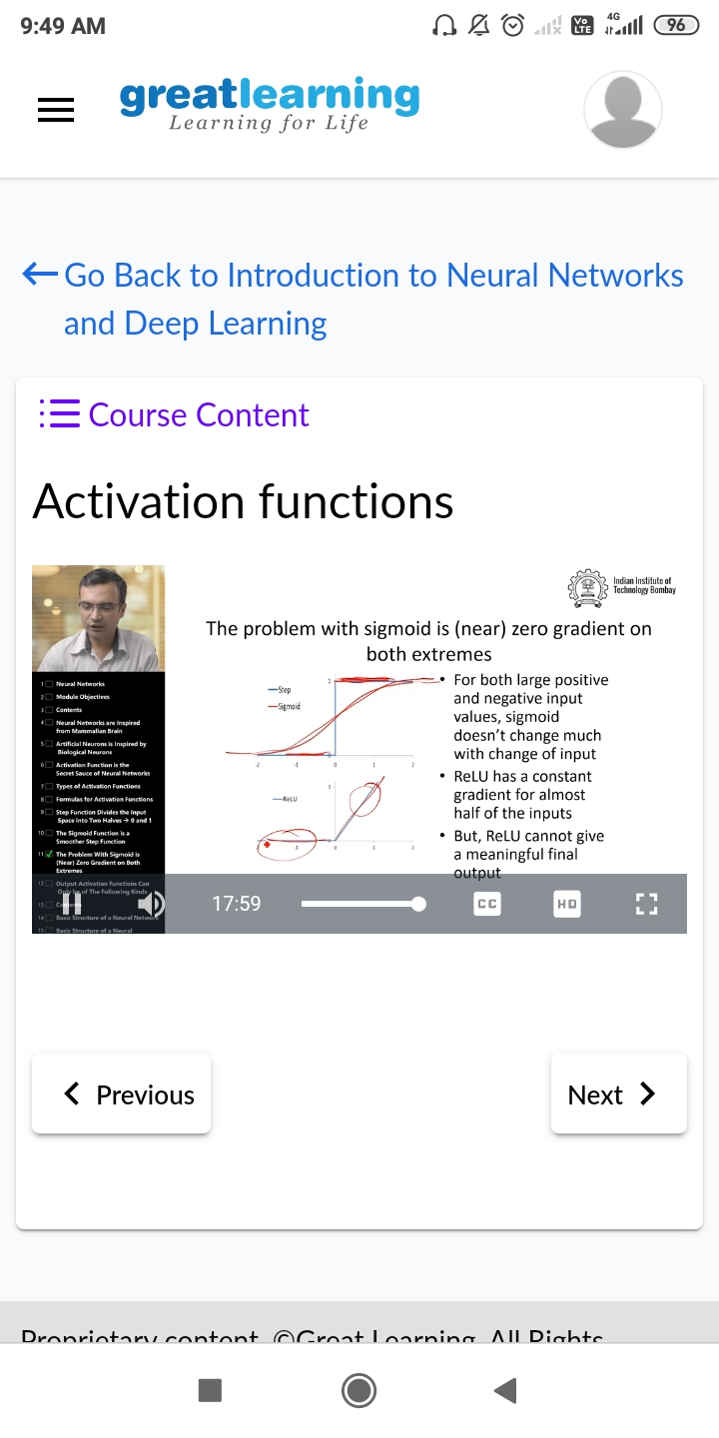

**CODING CHALLENGES DETAILS**:

**Problem statement 1: Write a Java Program to Segregate Even and Odd numbers.**

